Yoga and Meditation at SBH
Meet Our Instructors

J. Robin Moon

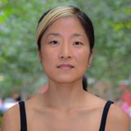
J. Robin Moon, DPH, MPH, MIA, is a registered yoga teacher (RYT) at Kula Yoga Project and Unity Yoga in Manhattan, practicing yoga in Iyengar, Ashtanga and Vinyasa traditions. She is also a social epidemiologist with an expertise in cardiovascular disease research, prevention programs and policy development. Robin is Senior Director of System Integration at Bronx Partners for Healthy Communities (BPHC), SBH’s DSRIP program, and has taught weekly yoga classes for the BPHC team.

Robin is devoted to bringing mind-body connection in her personal life as well as her professional work, and is pleased to share her yoga practice as a meditation to the SBH community.

“Yoga is so much more than the poses that we do. It is a process of understanding and respecting yourself and those around you. It is the cultivation of humility and generosity. Ultimately, it is about openness and exploration.” Dr. J. Robin Moon

Rebecca Koch
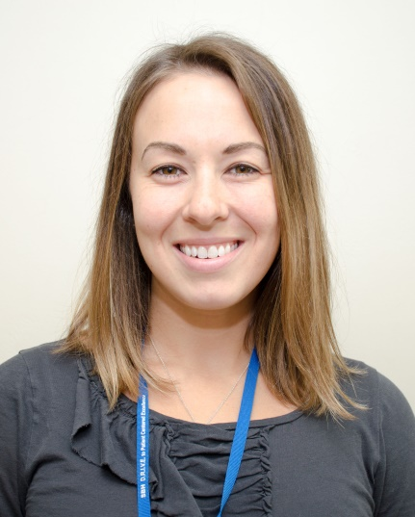
Rebecca Koch, RD, CDN, CNSC, is a Registered Dietitian-Nutritionist who works with the bariatric surgery program at SBH counseling patients before and after weight loss surgery. She was introduced to yoga in college and has been practicing yoga for over 10 years.

Her favorite style of yoga is vinyasa. She also has experience with bikram yoga and restorative yoga. She practices regularly and occasionally teaches at Five Pillars Yoga in Manhattan where she completed a 200 hour teacher training program in Spring 2018 with a focus on vinyasa yoga and yoga therapeutics. She enjoys practicing yoga for its many benefits on body and mind and especially enjoys teaching to share the practice with others.

